**DAILY ONLINE ACTIVITIES SUMMARY**

|  |  |  |  |  |  |  |  |
| --- | --- | --- | --- | --- | --- | --- | --- |
| **Date:** | | **21/05/2020** | | | | | |
| **Name of the Faculty** | | **Sayeesh** | | | | | |
| **No. of Students Allotted for monitoring** | | | | | **19** | | |
| **Progress** | | | | | **16** | | |
| **Whether collected report from all the allotted students** | | | | | **Yes** | | |
| **Online Test Summary** | | | | | | | |
| **Subject** |  | | | | | | |
| **Semester** |  | | | **Duration** | |  | |
| **No. of students Taken** | | |  | **Passing %** | |  | |
| **Certification Course Summary** | | | | | | | |
| **Course** | | IT Management - Software and Databases | | | | | |
| **Certificate Provider** | | **Alison** | | | **Duration** | | **3 Hours** |
| **Coding Challenges** | | | | | | | |
| **Problem Statement: Write a Java Program to Demonstrate a Basic Calculator using Applet** | | | | | | | |
| **Status: 23 students executed the program.** | | | | | | | |
| **Uploaded the report in Github** | | | | | **Yes** | | |
| **If yes Repository name** | | | | | <https://github.com/orgs/alvas-education-foundation/teams/sayeesh> | | |
| **Uploaded the report in slack** | | | | | **Yes** | | |

Online Test Details: (Attach the snapshot and briefly write the report for the same)

Certification Course Details: (Attach the snapshot and briefly write the report for the same)

Coding Challenges Details: (Attach the snapshot and briefly write the report for the same)

**Certification Course Summary**

# Completed the course in IT Management - Software and Databases

# Successfully completed the course with Assessment Score 80%

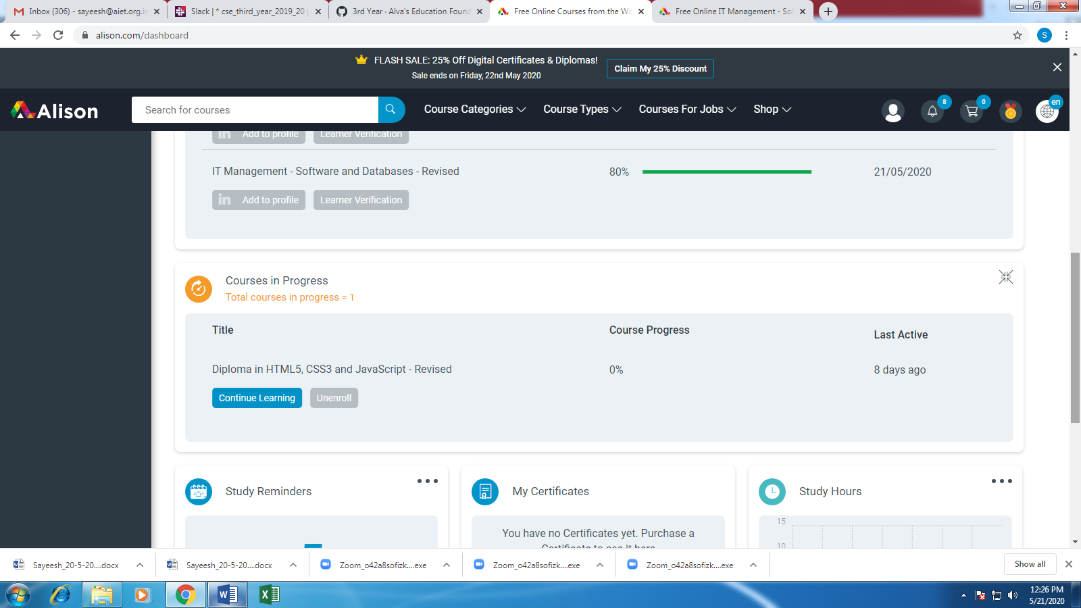

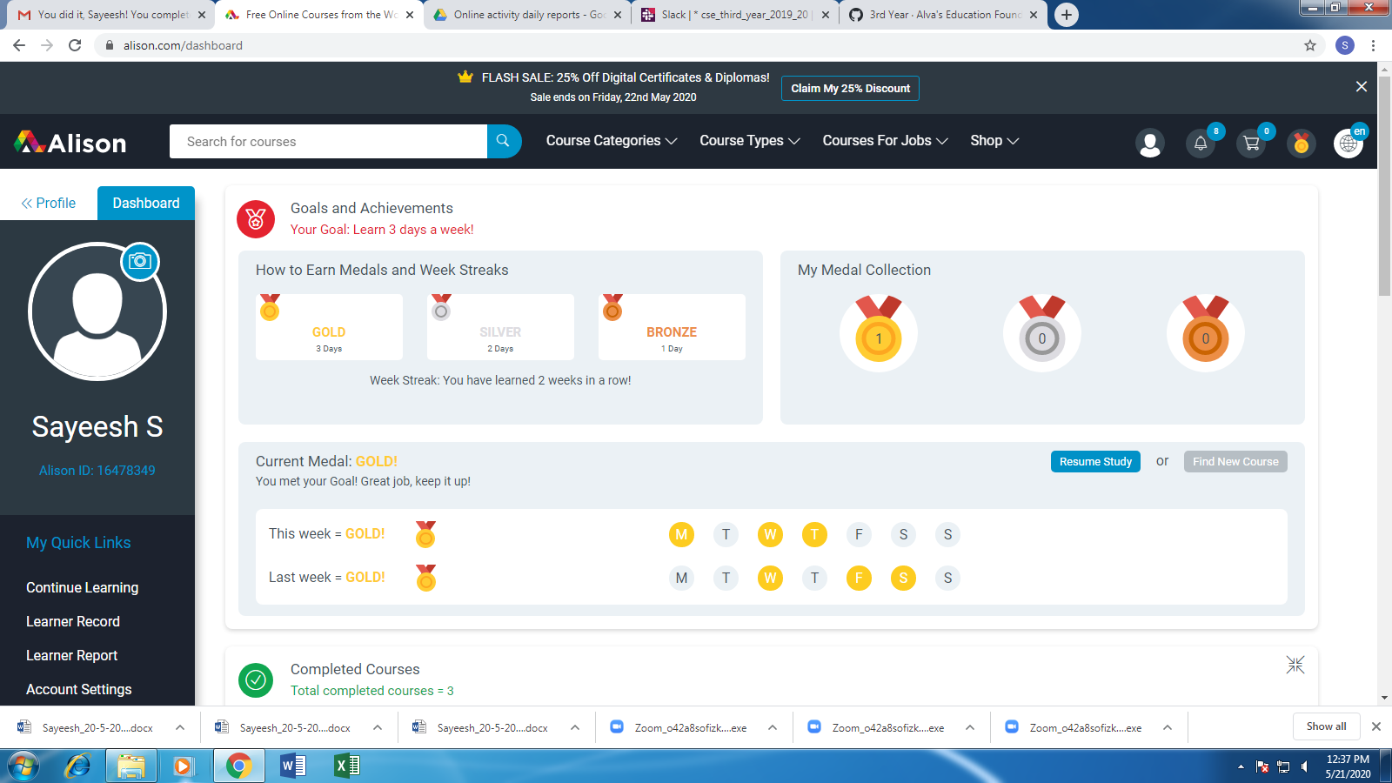

**Attended Webinar on Cloud Computing**

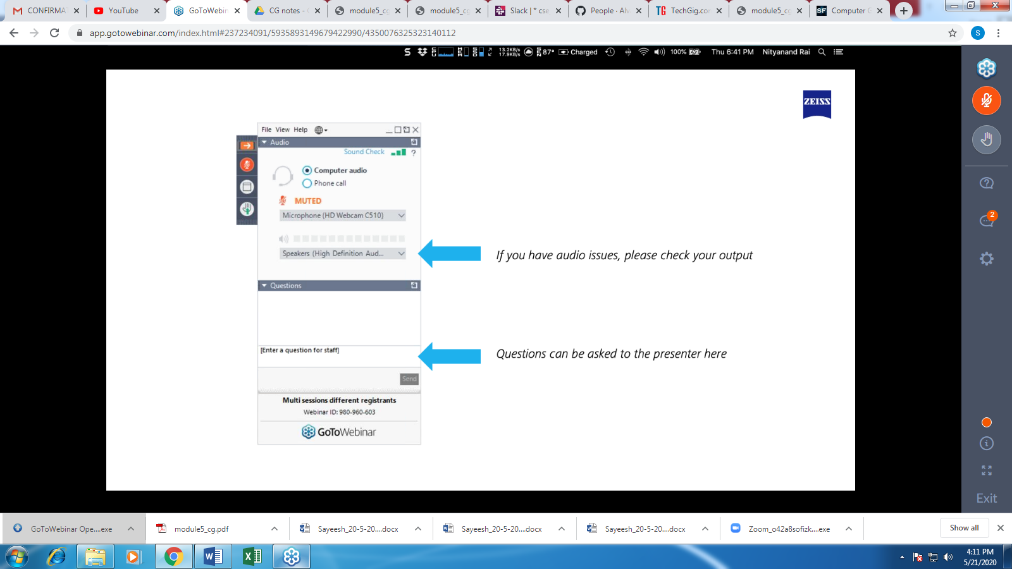

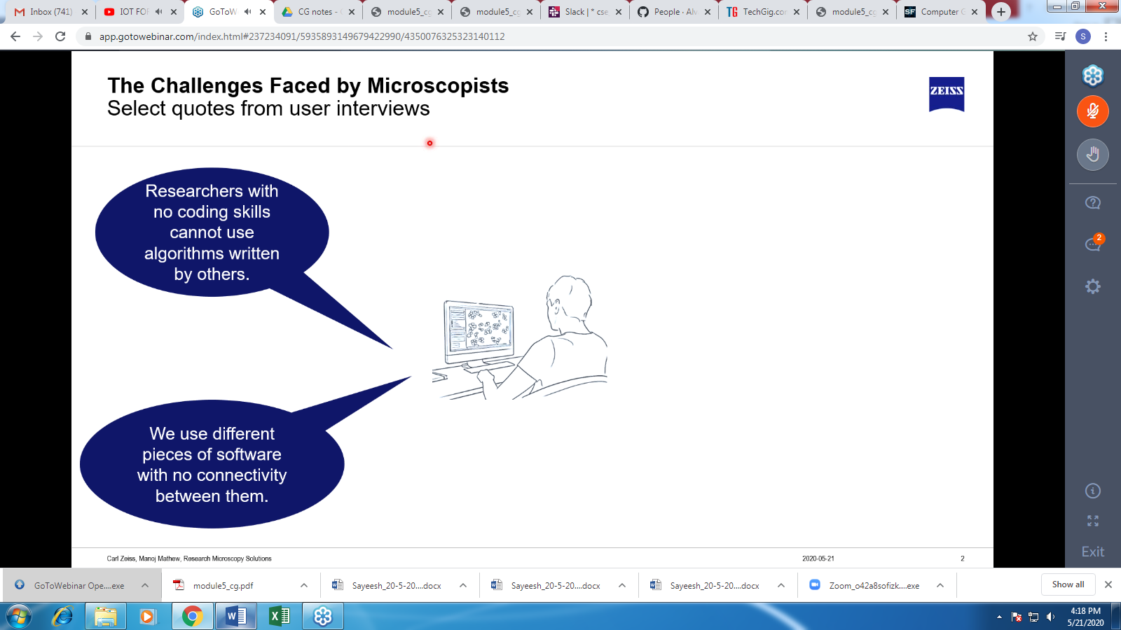

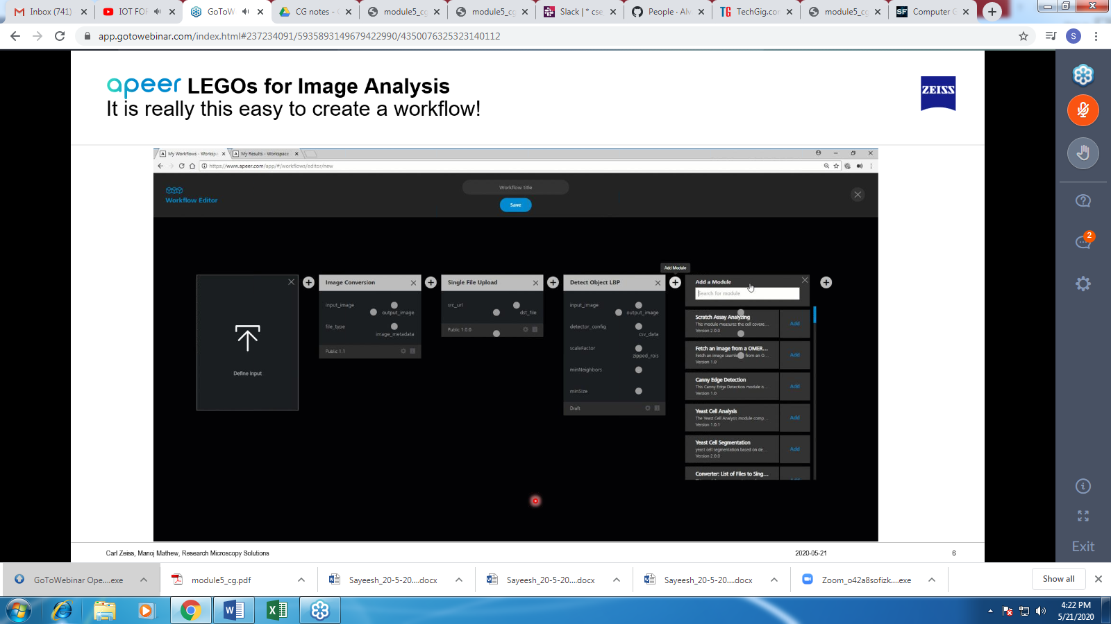

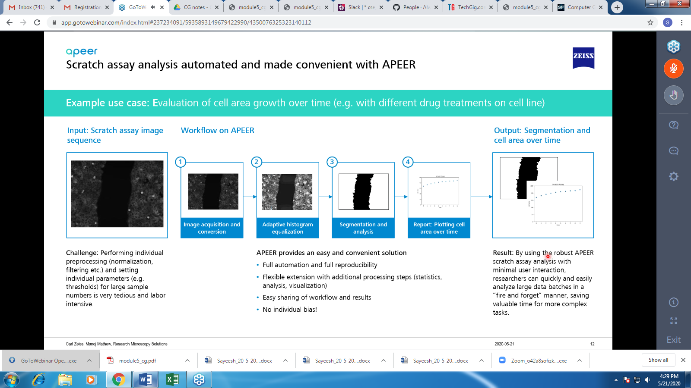

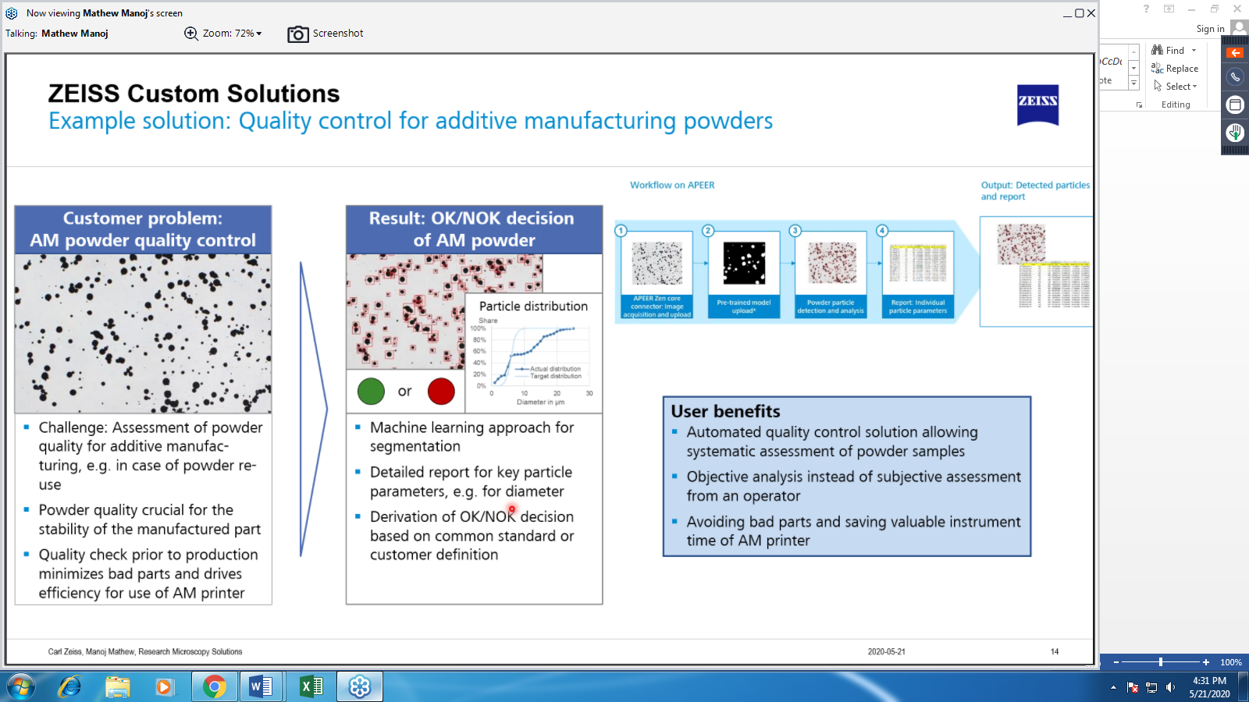

**Java Programming – Applets Concept explanation with syntax and example.**

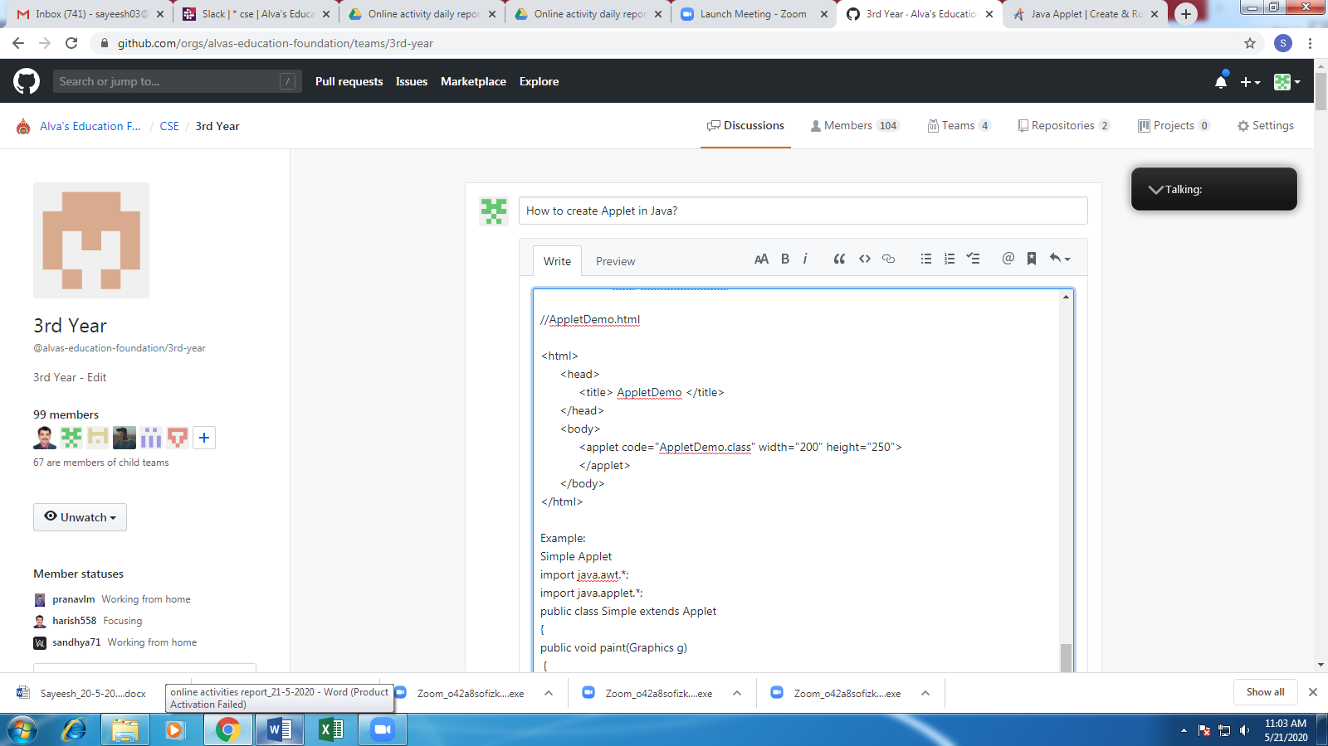

Today’s Java Problem Given:

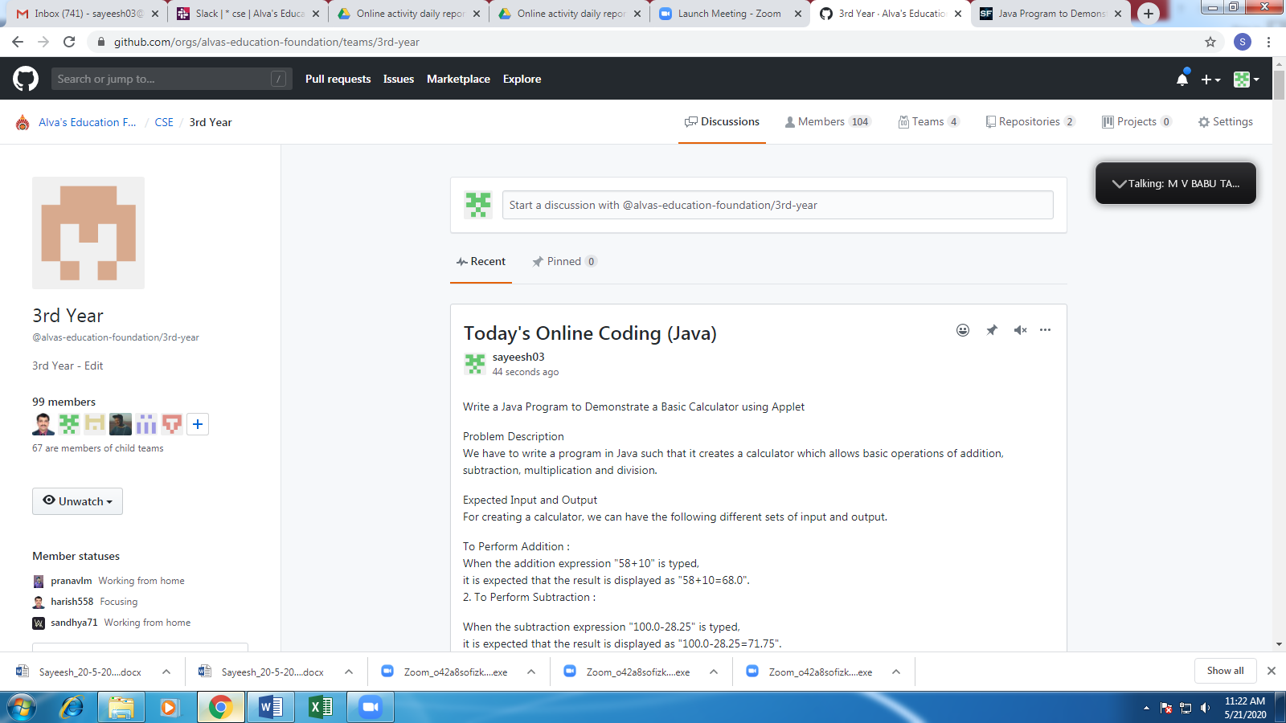

**Students Report:**

